**Lab 1: Introduction to Computers, Programs, and Python**

**Question 1:**

Write a program that displays the following table

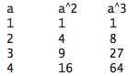

**Question 2:**

Write a program that draws four squares in the center of the screen, as shown in the figure below

